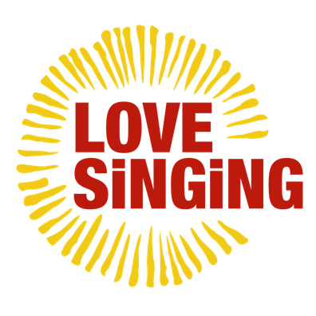

Press release under embargo until 00.01 on Tues 9 Feb 2021

**Winners of a nationwide search to pair up songwriters and community choirs announced.**

Producers of Scotland’s largest community choir, Love Music, have ‘blind date’ matched five of Scotland’s most talented songwriters with five community choirs busy keeping the music alive despite lockdown across the country, who will now come together to create five new works to share with the world in August this year, sharing their experience as they go.

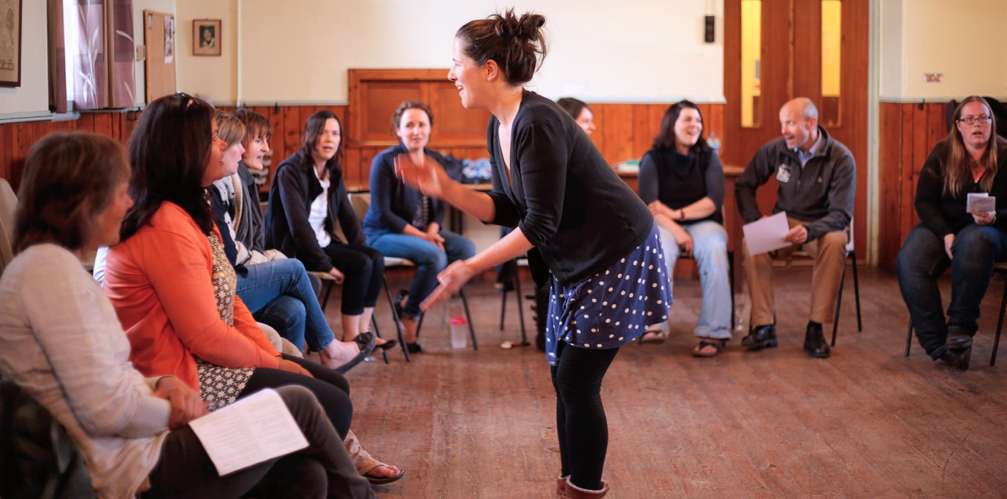Photo: Earnsong

The pairings of a diverse range of organisations and individuals across Scotland, from Moray, West Highlands, Falkirk, Lanarkshire and Perth & Kinross are:

**Sing Mor**, a small Scottish folk/roots project in rural Lochaber near Fort William, is only 18 months old but its singers are managing to run online weekly sessions and creating some lovely vocal recordings together. The song leader describes herself as self-taught and avidly learning on the hoof. Through the accessible nature of zoom, they now have regular singers from across the West of Scotland and the Islands. **Sing Mor will be working with** **Debbie Armour**, one half of the Scottish folk duo Burd Ellen, who are sonic adventurers combining innovation with a deep love of traditional song.

**Stonehouse Male Voice Choir** is one of longest formed groups which began in a builder’s yard in Stonehouse in Lanarkshire in 1936 as a lunch time sing. With over 40 members aged from 12 to 80+ the choir has managed to run some sessions using familiar repertoire but feel there is more to be done to try and bring more of their members on board and tackle the digital isolation some of their group are facing. As they haven’t learned any new songs since lockdown, they are excited to take up the challenge. **They will be collaborating with highly respected** **songwriter Penny Stone**. One of the most active song leaders in the Scottish sector Penny uses singing to support people living with chronic health conditions such as Parkinson’s and dementia and is passionate about peace and social and environmental justice.

**Fochabers Community Sing** in Moray is a project run by Lizzie, who has been a music teacher and music therapist and is now delivering fun and accessible community focused projects in her local area. Since the first lockdown she has turned her hand to making instructional videos of specially arranged songs, contemporary and pop, asking people to send in their own recorded versions and mixing them into joyful music films for people to share. **Their songwriter collaborator is emerging artist Zac Scott**. Zac is a Glasgow based acoustic singer-songwriter with a pop sensibility who has spent the past two years writing and recording a unique collection of songs inspired by Scotland and Iceland, leading to the release of his debut album in 2020.

**Earnsong,** a project from Comrie in Perth & Kinross who describe themselves as a close and supportive community, have worked hard to embrace new digital platforms. They love harmony and are up for anything. *Challenge us!* is what they said on their application. To keep local spirits up since March 2020, they have been making musical video gifts to share with friends and residents in their local care home. **Earnsong will work with Djana Gabrielle**, a French-Cameroonian singer-songwriter who has been honing her craft on the Scottish music scene for a few years. Djana was a 2019 Celtic Connections Danny Kyle Stage Winner.

  
Photo: Djana Gabrielle

**Freedom of Mind Choir** is a welcoming, inclusive and supportive project in Falkirk that provides opportunities for their members to focus on the benefits of singing for good mental health. They have been working hard to address digital exclusion during the pandemic and creating weekly learning videos. **They will be working on a new collaboration with Hannah Fredsgaard-Jones** who was born in Denmark and is now living in Glasgow. Hannah is a singer, songwriter, composer and audio documentary maker. Rooted in storytelling, her work encompasses folklore, memory, voice and intimacy.

**Stephen Deazley, Love Music’s artistic director said**: “The recruitment process for choirs was fascinating and moving in equal measures. Each application really conveyed their own style, a strong sense of identity, purpose and musical interests. The work and efforts that everyone is doing in this difficult time is so inspiring, producing videos and running online sessions, phone calls to stay connected, newsletters, songwriting, homemade DVDs, intergenerational and family projects, filmed musical gifts for friends and family living in care settings - all are testament to the importance of community singing to our health and creative well-being. You get a real sense of determination, resilience, personal and collective motivation and great acts of kindness – there were more than a few tears on our ‘at-home’ desks during the selection process.

“A big thanks to all our applicants. It was great to be introduced to such a range of choirs and songwriters from the length and breadth of Scotland. This country has more than its fair share of diverse songwriting talent and such a long history of musical innovation especially in folk and indie music, it’s always punched well beyond its weight. We were truly inspired, and sad to have to select only five.”

***Love Singing*** is a community engagement initiative aimed at promoting and supporting creative, healthy singing communities across Scotland. It focuses on collaborative practice, connecting choirs across the country, addressing digital isolation, increasing tech skills and confidence, and buddying up with professional songwriters to commission five brand new songs and a bank of useful and accessible song resources, providing information and motivation to help people stay connected in these challenging times. The project is made possible with funding from Creative Scotland.

The 8-month project through to August 2021 will tackle the ongoing challenges of distanced rehearsals and remote learning head on, sharing the journey as it happens through a series of blogs, and creating an online information bank of what is learned, sharing the trials and triumphs with choir leaders across Scotland.

Project title is ***Love Singing***  
Love Singing website: [https://sing.lovemusic.org.uk](https://www.sing.lovemusic.org.uk)

Project is run by charity ***Love Music Productions Ltd***  
Love Music website: [https://lovemusic.org.uk](https://www.lovemusic.org.uk)

More images of choirs and songwriters here.

Hashtags: #LoveSinging #LoveMusic

ENDS

For more information, please contact Susie Gray, The Corner Shop PR, [susie@thecornershoppr.com](mailto:susie@thecornershoppr.com) 07834 073795

More about Love Music

### Mission

Love Music inspires and empowers people to be curious, creative and adventurous with music, regardless of their skill base or background, raising aspirations and changing lives.

### Vision

For our communities to have no-barrier access to the highest quality musical encounters that leave them inspired to engage in their own creative journeys and open to new ideas and experiences whilst increasing their confidence, well-being and personal resilience.

### Values

Love Music’s work focuses on:

**~ No-barrier \***,**accessible** **experiences**, and a **culture of** **equality** across all activity **~ The power of learning** and **the educational impact** on participants  
**~**Providing the **highest quality experiences** with exceptional artists and practitioners  
**~ Embracing diversity** and providing access to **culturally diverse music  
~**Creating **inspiring experiences** that enrich participants’ lives, and inspire their families and communities **~ Insisting on excellence**and being**artistically ambitious  
~ Innovation**, enhancing its work and enriching the sector through **new thinking** around delivery, planning and engagement

* No-barrier access means that wherever possible we do not discriminate on the basis of ability to pay, social background, previous experience, musical skill, or physical or mental ability, and that we have an aspiration to deliver inclusive and accessible experiences to all who wish to take part.

### What we sdo

Love Music creates and produces a portfolio of adventurous participatory projects and new music through which young people and communities can come together with musicians in a professional setting and participate in inspirational music making.

There are 2 clear strands to our work: Community and Young People, and under each strand we offer a number of projects and opportunities for people to participate. Click on [**Projects**](https://www.lovemusic.org.uk/projects/) in the menu to find out more about each project.